Final Steering Committee  Péronne, France  18 and 19 September 2009 | 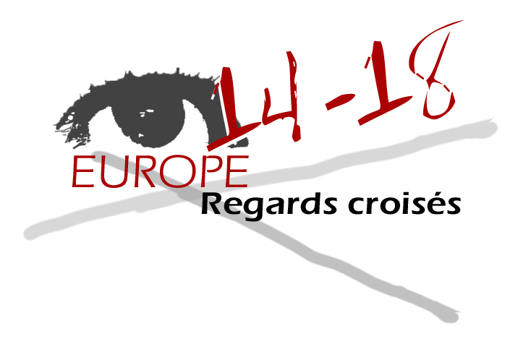

«The love of war is so deeply rooted in the heart of men, so that after national wars, civil wars are feared » René QUINTON, Maximes sur la guerre,(Maxims on war) collection Les Cahiers verts, Paris, 1930.

Two world wars later, The Belgians, French, German, Austrians, Italians, Poles and Romanians went to the end of the « Crossing Views adventure » whose beginnings dated back 2004.
The Steering Committee of the Project: Crossing views on 14-18 held at Peronne in September 2009 has just put an end to this transnational enterprise. (temporarily?)

Agenda :

Meeting agenda Friday 18th September 2009.
- Presentation and adoption of the training module directions for use.
- Presentation of module resources exploitation tracks.
- Elements of analysis on the pupil questionnaire.
- Visit of the Historial.

Meeting agenda Saturday 19th September 2009
- Dissemination
- Long term exploitation of the site
- Circuit battle of the Somme.

Preliminary remark :

The choice of the site where the last committee was held (Historial in Peronne) is fully justified within the project « Crossing views »..

EXTERNAL EVALUATION

- Directions for use

Presentation of the directions for use proposed by the AEDE that has included the modifications since the last technical committee, especially a standardization of references.

These directions for use still present the difficulty of translating long text for some of our partners.
Yet it had been recalled at the steering committed in March 6th and 7th in Lille that each partner had to decide what needed to be translated and achieved this translation.
All indispensable elements such as the structure of the module must absolutely be translated by everyone.

For other partners, conversely, the problem of translation is an asset. The use of other languages allows an opening towards schools with international vocations or a pluridisciplinary approach in conventional schools.
The module, thanks to the multilingual and pluriformal documents that cannot be hardly found in national handbooks offers a unique opportunity of a broader view.
The significant presence of iconographic documents enables to circumvent the difficulties posed by the use of multiple languages.

The directions for use that are necessary to prompt the user to move in the diversity of resources was adopted unanimously.

These directions for use match the stated objectives.

- CROSSING VIEWS : a methodology

There is no settled definition of the concept of crossing views.
The text the Romanian partner presented to us is also adopted.
It is indeed necessary to initiate reflection on the crossing views concept which is an innovative educational approach.
This first contribution should be in the module and on the forum.

- Examples of exploitation

Partners are invited to present exploitation tracks of the module.
These tracks reflect the involvement of each partner in the whole project. Their contents like their impacts are variable.

The user is confronted with a multiplicity of documentary sources: either official (curriculum) or not, types, origins or different historical times.
It is proposed to better identify the level and the age of the users of the modules documents. A classification by type, theme or origin of the material might be appropriate.

It is mainly required to multiply the “lesson plans” taking into account the necessity to get out of a national short-sighted view.
The primary justification for a crossing view approach involves the establishment of a European historical consciousness.
The « crossing views » projected onto future generations are the door to the development of humanistic values and democratic attitudes by a reflection on the past and the future of Europe.
A European citizenship is rooted in the acceptance of different viewpoints, a broadening of a vision of history in relation to each other.
This module serves as an example of many possibilities.
Its dissemination both towards universities and educational structures is consistent with the crossing view approach.

- Dissemination

In the short term, each partner is asked to complete 10 sheets by September 30th. They can add newspaper articles if any.

In the medium term, the partners plan several levels of extension. Their desire to continue the search for educational materials is unanimous.

The First World War period can be tackled within an intergenerational memory relationship, but it must be incorporated essentially in the training for future teachers.

If not, the participants wish to widen the cooperation of the pupils exchange. The comparative approach can be proposed thanks to the richness of the documents in the module.

We can invite teachers to use the module showing the interaction of the educational trail between the existing module and the external educational material.
It is considered that it is necessary to go beyond Eurocentrism and look elsewhere since the conflict was global.
The opening to further resources more pluridisciplanary such as music or sciences is essential.
Moreover, it is possible to create material with other teachers, including new national partners and even extend thematic to other conflicts like the Second World War. To put it in a nutshell, it would be interesting to export the « crossing views » methodology..

- The Forum

The debate about using the forum is about the eternal questions of this tool :

- too open, the content might veer onto slippery ground…
- too close, it lacks interactivity between users.

The meeting agrees with the use of a password owned only by partners.

- Analysis of the pupil survey.

For lack of time and despite the agenda, the analysis made by M. Plumet was not presented.
It enabled to orientate the contributions of resources towards what lacked, and refine the model of the use of the module and open the issue on contents assessment.

- Highlighting the strong and weak points.

Strong points :
- choice of the place
- richness of documentation
- the awareness that working together is possible despite the initial difficulties.
- educational opportunities of the crossing views approach.
- adoption of the directions for use.

Weak points :
- translation of the texts into all partners’languages.
- Some exploitation model are still to be developed.
- To make the practical approach adopt by schools is to be achieved.
- Time management during the committees.
- Balance betweens visits and plenary sessions.

The desire to continue is always expressed between partners of a common project, who learned to like each other.
In term of extension, unfortunately Inforef will have no available staff after September 30th.
The IFP could occasionally take it over, especially to facilitate the access to the forum.

Michel Herode
Chargé de mission
Communauté française
External Evaluator.

