5ème Comité de pilotage  Péronne  September 17 – 19, 2009 | 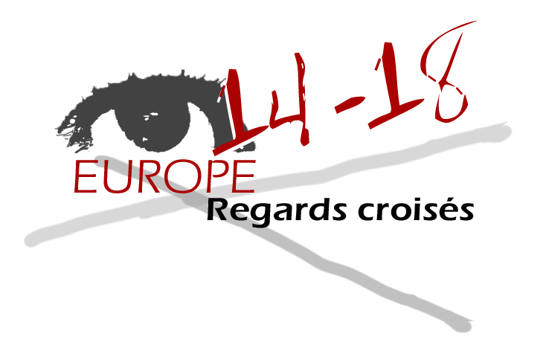

Questions for external evaluation

1- Do the current contributions match the stated goals?

Yes the contributions corresponded to the project goals. But the partners contributions show quantitative differences, especially not all contributions have didactic suggestions.

2- How do you assess the involvement of each partner during the steering committee and the project in general?

The presentations of the participants brought more insight in there work, some shows only a report of the activities; others presented examples of their work.

3- What do you think of the proposed activities for the steering committee and their organization (time management, balance between different activities, etc...)?

Time-management was o.k. but some partners often were behind the schedule. In case of a new project it would make sense, instead of a central material implementation to use a content management system that allows all partners the implementation of materials.
A problem were the interviews with pupils and teachers because of data security in Germany on one hand and the fact that universities have no partner schools for these purpose.

4- Do you think this committee offered a clear vision on the progress of the project and its achievements?

Yes the partners presented their material and the greater part of it was implemented.

5- What do you think of the systems established to ensure internal and external communication?

The newsletter (French, English and in phase 3 German) was an important point for extern communication. The response on mails sometimes was delayed.

6- At this stage of the project, you can already see the benefits it could bring to the educational community?

The implemented materials open a lot of chances to work multi -perspective. On one hand it possible to focus on a special topic (e.g. cemeteries) on the other hand to work in longitudinal or cross sections. There exist some suggestions for cross subject work,

7- Suggestions

As a fact that French and English are the working languages and for the future use of the project materials it is absolutely necessary to translate all sites in both languages respective from the mother tongue to English. But it would make sense for the target of the project to translate also in German because WWI is up to now an important topic. Only in that case German teachers and pupils will make use of it. At the moment only the home pages are translates in German, Polish, Romanian and Italian, behind these pages in most of the cases is French sites.

The top buttons on the starting page and the subdivided items correspond with the agreements of Vienna and Lille.

Beside of language problems user who is not involved in the project may have problems to find interesting materials. Therefore it will be helpful to have a data bank and by the mean of a search machine the user get the necessary information. The listed items should be interactive. (Look to http://www.didactics.eu/index.php?id=suche: write Kompetenzen)

Also important will be a similar data bank fort he didactic suggestions.

The didactic suggestions should inform about the age group. (14-18, 15-18).
On German sites there are some spelling problems, a native speaker should look for correction.

Important for the sustainity would be a follow up project because only in this case the maintenance of portal could be financed. Also it would be possible to complete some topics.
Important for the sustanity also would be to contact Teacher associations (e.g. AEDE respectively their national sections) universities (didactic departments) and pedagogical faculties in the member countries to publish this portal.

The visit of museums in Vienna, Ypres and Péronne shows an interesting field for future work. (e.g. How could teachers and pupils make use for multi perspective this teaching of this sources, expositions without visiting.

In future project each participant country should have a combination of universities (for the scientific and evaluation part) and teachers/schools (for the didactic and improvement)
It would be interesting if it could be managed that schools from the member states work together with the same topic and sources.

Mag. Dr. Klaus Edel, Wissenschaftlicher Berater, Fachdidaktikzentrum Geschichte, Sozialkunde und Politische Bildung, Universität Wien.

