Third Steering Committee  Vienna, Austria  26th and 27th September 2008 | 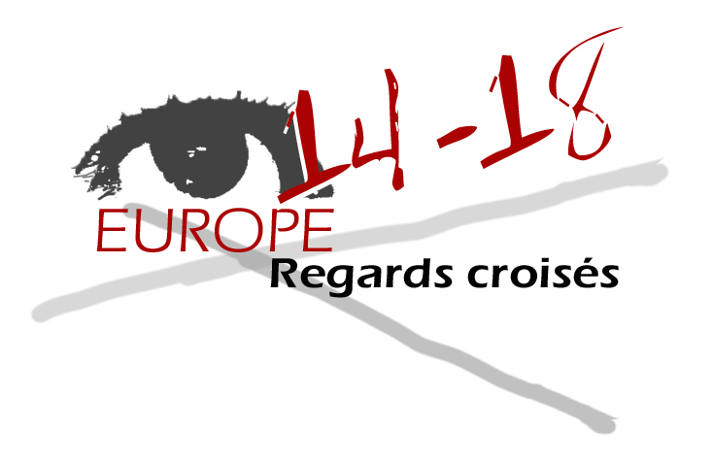

- Do you think that the contributions meet the project objectives that had been defined?

1.a Objectives reminder

- What place is devoted to the First World War in the teaching of history? (curricula and handbooks) ?
- What aspects of the conflict are tackled in lesson plans? How are they broached ?
- Is there any impact in the new historiography (brutality …)?
- Is it possible to design some tools, the development of active methods and some models of transnational training?
- To emphasize collective representations of this war (memory traces – media…)
- What place is devoted to the view « on the other »in the teaching of this conflict?
- How to build instruction in a European history through the study of the Great War?

1.b National contributions – comparison.

The different partners have completely met the requirements of Axis 1.
Indeed, the national curricula in history are all listed and make a comparaison possible. Yet, only the German contribution (academic partners) show concern about an analytic methodology.

Each partner tends to favour the one or the other issue that is peculiar to him. All the documents that were collected are varied and the centralization of the contributions should offer an easy access and favour exchanges.
Yet, as far as Axis 2 is concerned, a comparative analysis on teaching practice through documents and other tools that were presented seems to be difficult.
It is mainly a juxtaposition of free individual contributions.
That diversity makes you wonder how relevant is the very choice of the subjects that were broached.
Indeed, it is fundamental to distinguish lesson plans from thematic documents.
The multiplicity of approaches and tools make the institution of comparison criterion completely impossible. Furthermore, it is more difficult to make distinctions and links between lesson plans models and topics (thematic)
Conversely, this disparity offers a wide range of elements for external users’ research.

The contributions that cover Axes 3 and 4 are still incomplete.
It would have been necessary to work collectively beforehand on the building of an analysis grid and the exploitation of memory traces, the collective representation in media, the visit of historical and/or memory sites (museum and sites).

1.c Time Limit /deadline

The series of delays in the contributions availability remains a major stumbling block of the project. Indeed, most of the time, contributions rely on people’s willingness.
Their involvement is more formal than restrictive.

- How do you evaluate each partner’s involvement during the steering committee and most generally, in the project?

2.a The presentations

The meeting of the steering committee is essential to have an overview of the work that is achieved. Obviously, the types of presentations are varied. Yet, asking each partner to present their production is more a juxtaposition of elements than a sharing of a collective creation.
We retain the impression of a series of different elements without discussing the content:
that is to say the comparison of the different approaches in the light of the national issues of teaching this period of history within the European framework today.

2.b The visits

The Heeresgeschichtliches Museum visit , organized by our Austrian partners in Vienna meet perfectly the demands of Axis 3.

Such a site allows to give concrete expression to the questions related to specific characteristic (not to say nationalist) of the twentieth century history.
This initiative should encourage the other participants to work on the same supports in their environment, then to network their expertise.
Following this visit, we missed the opportunity to list a series of criteria that would allow to cross views during the visit in museums dealing with the same theme (for lack of time undoubtedly).

- What do you think of the activities and their organization suggested during the steering committee (time management - (different activities balance, etc.)?

3.a Training module

Besides the conditions of the different contribution in all fields, the essential of work consisted in the building of the training module.
A double entry table that goes over the items (causes, key events, the conflict aspects, peace treaties and consequences) and a toolbox (iconographic documents, texts, traces).

It seems to be necessary to keep in mind that this training module is meant for external users, that is to say: teachers, pupils…).
This is why the module has to be tested out by external participants on a voluntary basis.
It has to be as exhaustive as possible, hence the multiplicity of elements in rubrics.
Moreover, this module must be perfectly and efficiently legible hence the difficulties in classifying available documents.
The topic debates were the differentiation and the clarification of documents and tools that were proposed.
The different interventions during this steering committee were synthesized. The module should be available on the site very soon.

3.b Structure

The structure of the steering committee is more problematic.
It seems that the different roles or functions are not well-defined. This is more a question of status.
This can be felt especially in the time management within plenary work: a too complete freedom is given to the participants.

- According to you, does this committee offer a clear view on the project state in progress?
- Its achievements?

The meeting in Vienna allowed to give concrete expression to the importance of the partners contributions, both in term of variety and lack. It enhanced every partner’s involvement through awareness about practical issues such as time limit respect…

- What do you think of the means that are available to ensure internal and external communication.

It is essential to organize meetings such as that committee in Vienna, otherwise contacts between partners would be restricted to the e-mails sending and newletters reading.
The communication will be more interactive through a chatroom.
This medium is fundamental to the continuity between partners and the opening to external users.

The translation issue, as far as time and cost are concerned, are due to its centralization.
But is it possible to operate differently ?

Some dissemination efforts have still to be made by lots of partners. They seem to have difficulties to find schools in their own countries.
Is it a problem of structure or dynamism?

7. At this stage of the project, can you already detect the benefits that could be brought to the educational community?

7.a the chatroom online setting.

The impact analysis of the different tools on the external user, the return of information from teachers towards the promoter should be easier thanks to the chatroom online setting.

7.b An indispensable first step

The spreading of the different and numerous viewpoints is potentially constructive.
The development of “crossing views” principles implies the definition of pedagogical objectives so as to elaborate the teaching of the First World War in a European perspective rather than national.
It would be necessary to work on the collective building of lesson plans for external users.

