AXIS 3 : museums, historic sites, courses
AUSTRIA

Description - practical information
Practical information:
Name of the museum, site and course : Museum 1915-18 from the Ortler to the Adriatic Sea
Address / location : City Hall, A-9640 Kötschach-Mauthen
Schedule : 15.5. to 15.10.2009
Monday to Friday from 10am to 1pm and from 3pm to 6pm/Saturday, Sunday and on holidays:2pm to 6pm
Contact : Tel: 0043 4715 8513 32, Fax 0043 4715 8513 37
Website : http://www.dolomitenfreunde.at

Description of the contents :
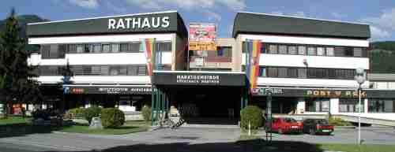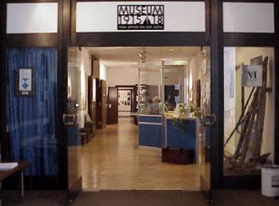
This museum was installed on an area of more than 600m2 in the city hall of the markettown of Kötschach-Mauthen (Carinthia) by the association of the “Friends of the Dolomites” and it was opened in 1992.
- It shows the futility of war by the examples of the fates of simple soldiers and civilians of both warring parties during World War I at the south-west front.
- It documents the front from the Ortler mountain to the Adriatic Sea by showing more than 1500 historical photographs and documents, numerous exhibits as well the the reconstruction of Alpine positions.
- It is an exhortation for peace – drawn from the understanding that conflicts may not be solved by means of war.
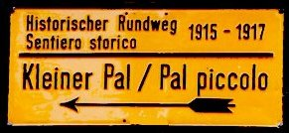
Specialised literature, also for youths, is available at the museum (look for the bookshop). The museum has been adapted for disabled persons.
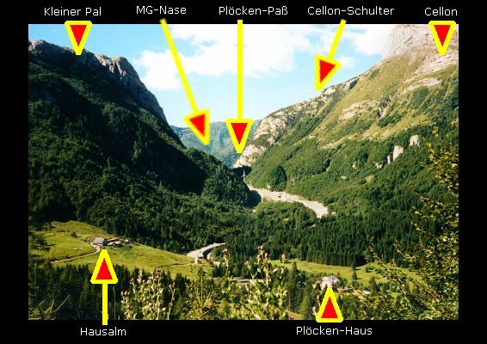
Especially in connection with the open-air museum dedicated to the ‘War in the Mountains 1915-18 in the Plöckenpass region’ (about 12 km from Kötschach-Mauthen) visitors will be able to get a particularly memorable picture of the human tragedies at the Austro-Italian border, which is so peaceful at present.

