AXIS 3 : museums, historic sites, courses
AUSTRIA

Description - practical information
Practical information:
Name of the museum, site and course : Heeresgeschichtliches Museum Wien
Address / location : Arsenal Objekt 1; A-1030 Vienna
Schedule :
Contact : Mag. Richard Hufschmied
Website : http://www.hgm.or.at

Description of the contents :
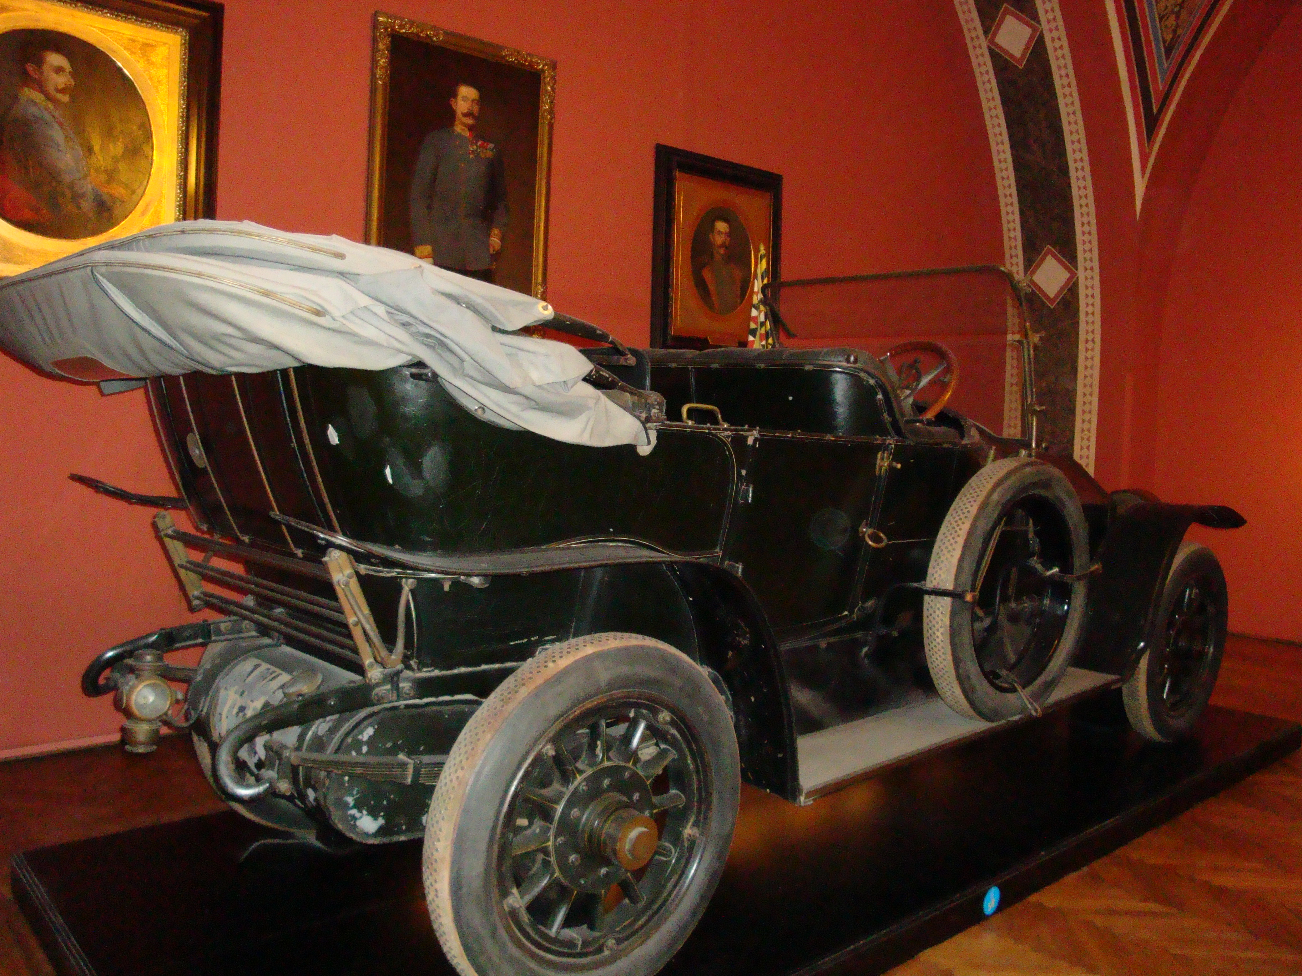
The car in which Erzherzog Franz Ferdinand was assassinated on June 28th, 1914 / his blood-soaked uniform-coat / symbols of the Austro-Hungarian monarchy / flags / uniforms / examples of propaganda-material / manifesto of Emperor Franz Josef I. „An Meine Völker“ / visualisations of battle fields, soldiers‘ equipment (also pieces of booty) / pieces of evidence of technical development (airplane „Albatros 1“, models of vessels and warships) / war-equipment / expressive paintings by Albin Egger-Lienz (e.g. „Die Namenlosen“) as an indictment of war / living-conditions of soldiers and civilians
Foto : Fritz Mairleitner – AEDE Österreich / Wien

Teaching aids (pedagogical support): yes / no
The pupils can repeat the topics by means of work-sheets by themselves. There are guided tours and workshops.

Use and integration in the history lesson
Personal experience:
I visited the museum with pupils, we had a guided tour and the pupils filled in questionnaires afterwards.

Integration in the lesson:

How did you integrate this activity into your lessons devoted to the 14-18 War?
After dealing with the topic in the classroom I generally use the visit to the museum to visualize the multi-ethnic Austro-Hungarian situation in Austria, the Balkan-Wars as important reasons for the war, the enthusiastic beginning, the technical development, the cruel warfare.

The end result of this experience
Strong points :
The exhibition is well organised, the objects and documents dedicated to the war are representative, but not too numerous. The presented pedagogical questionnaire is adequate for younger pupils and helps them concentrate on the important facts. The guided tour was very informative.
Weak points :
The questionnaire for the pupils is not adequate for pupils aged 16 and over – I would prefer questions demanding the knowledge of a wider context.

