AXIS 3 : museums, historic sites, courses
AUSTRIA

Description - practical information
Practical information:
Name of the museum, site and course : Examples of memorial sites in Austria
Address / location :
Schedule :
Contact :
Website :

Description of the contents :
Memorial inscription at a family chapel near Pfandlhof-farm in Kaisertal/Tyrol
(Photograph by Dr. Klaus Edel, University of Vienna)

Funeral slab for the crew of the k.&k. submarine U20 (cemetery of the academy in Wr.Neustadt, Günserstraße, A-2700 Wr. Neustadt)

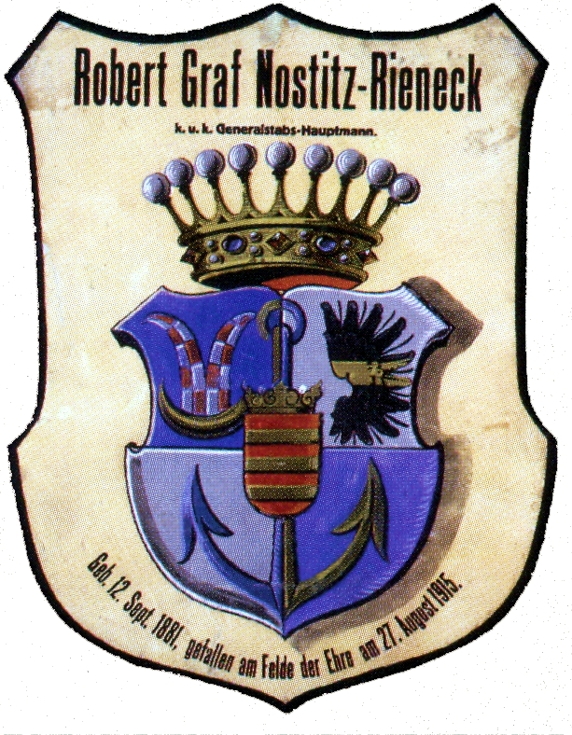

Mourning shield for Robert Count Nostitz-Rieneck
(Funeral museum Vienna, 19, Goldeggasse, 1041 Vienna, website http://www.bestattungwien.at/bw/ep/channelView.do?channelId=-26858&pageTypeId=13569)
