AXIS 3 : museums, historic sites, courses
AUSTRIA

Description - practical information
Practical information:
Name of the museum, site and course : Memorial Site “Outer Burgtor” in Vienna
Address / location : Burgring, A-1010 Vienna
Schedule :
Contact :
Website : http://de.wikipedia.org/wiki/%C3%84u%C3%9Feres_Burgtor_(Wien)

Description of the contents :
„Laurel for our heroes of 1914-18“
(Outer “Burgtor”, laurel wreath and coat of arms)
This fund-raising drive aimed at creating laurel wreaths (wreaths of victory, not funeral wreaths) from “an alloy that is unsuitable for producing mortal weapons”. Each donor could either have his own name engraved in one of the laurel leaves or he could dedicate this leaf to one of the soldiers at the front. The donor could sign his name in an honorary book and he received a memorial document. This fund-raising drive was started on June 1st. The profit of the fund-raising drive was offered to the ‘k.k. Fund for the Austrian Military, for Widows and Orphans’ or to the ‘war-time welfare institution’
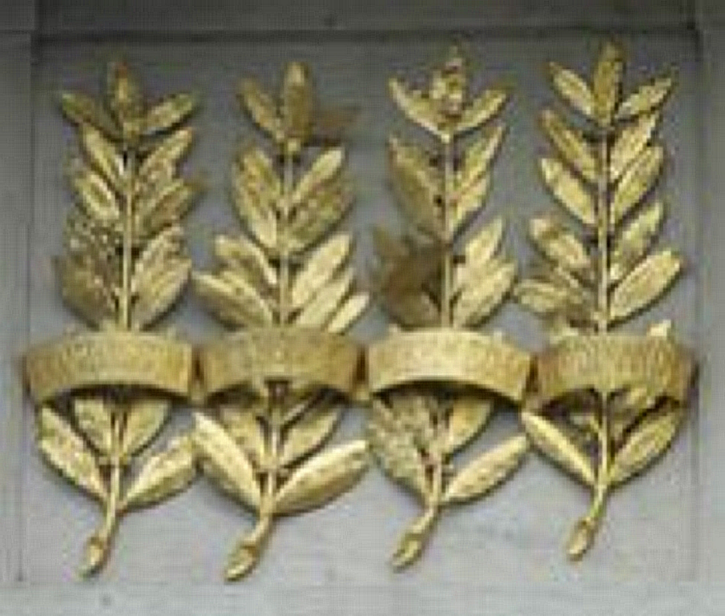
Laurel branches for the supreme commander
The most well-renowned donors were Emperor Francis Joseph I. (Austria-Hungary), Emperor William II. (German Empire), Great Sultan Mehmed V. (Osman Empire) and King Ferdinand I. (Bulgaria).
The four gold-plated laurel branches in the middle of the front pointing to “Ringstraße” between the laurel wreaths and the coats of arms of the countries and cities of Austria (“the countries represented in the “Reichsrat”) remind of their donation. Additionally the epigram ‘LAVRVM MILITIBVS LAVRO DIGNIS MDCCCCXVI’(‘the laurel of the soldiers deserving of laurel, 1916’) was put up.

Crypt in the ‘Burgtor’
(photograph by Dr. Hedwig Kadletz)
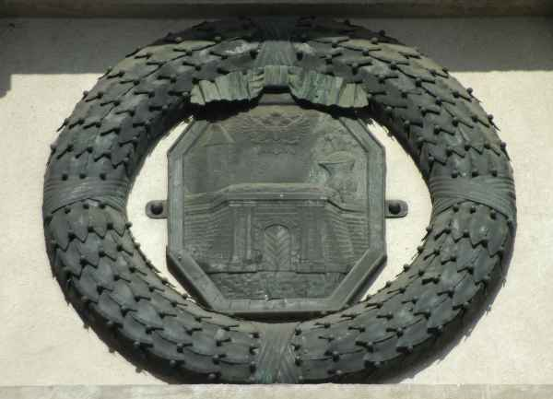
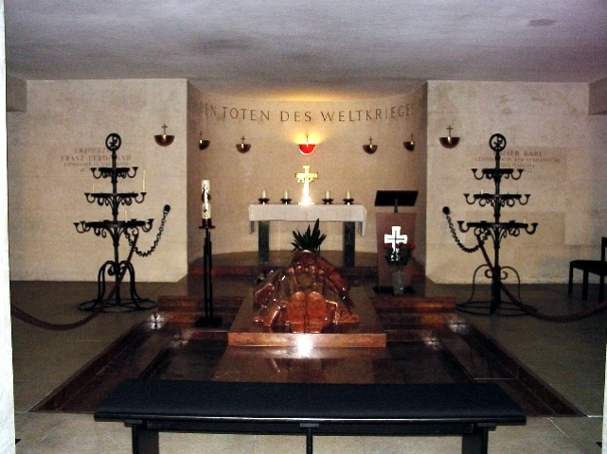
In the northwest wing of the gate a crypt, a sacred chamber, was installed and dedicated to the memory of the dead of World War I together with the ‘books of heroes’ that were laid out there. The ‘books of heroes’ list up all the names of Austrians who sacrificed their lives in the war between 1914 and 1918. All in all there are ten ‘books of honour’, one for each federal country, two only for Lower Austria. The pages of the books are turned every day.

