AXIS 3 : museums, historic sites, courses
AUSTRIA

Description - practical information
Practical information:
Name of the museum, site and course : Memorial site at Vienna Central Cemetery
Address / location : Simmeringer Hauptstr 234, A-1110 Vienna,
Schedule :
Contact : Tel. 0043 1 76041
Website : http://de.wikipedia.org/wiki/Zentralfriedhof_Wien
http://www.wien.gv.at/kultur/friedhoefe/orte/zentralfriedhof/index.html

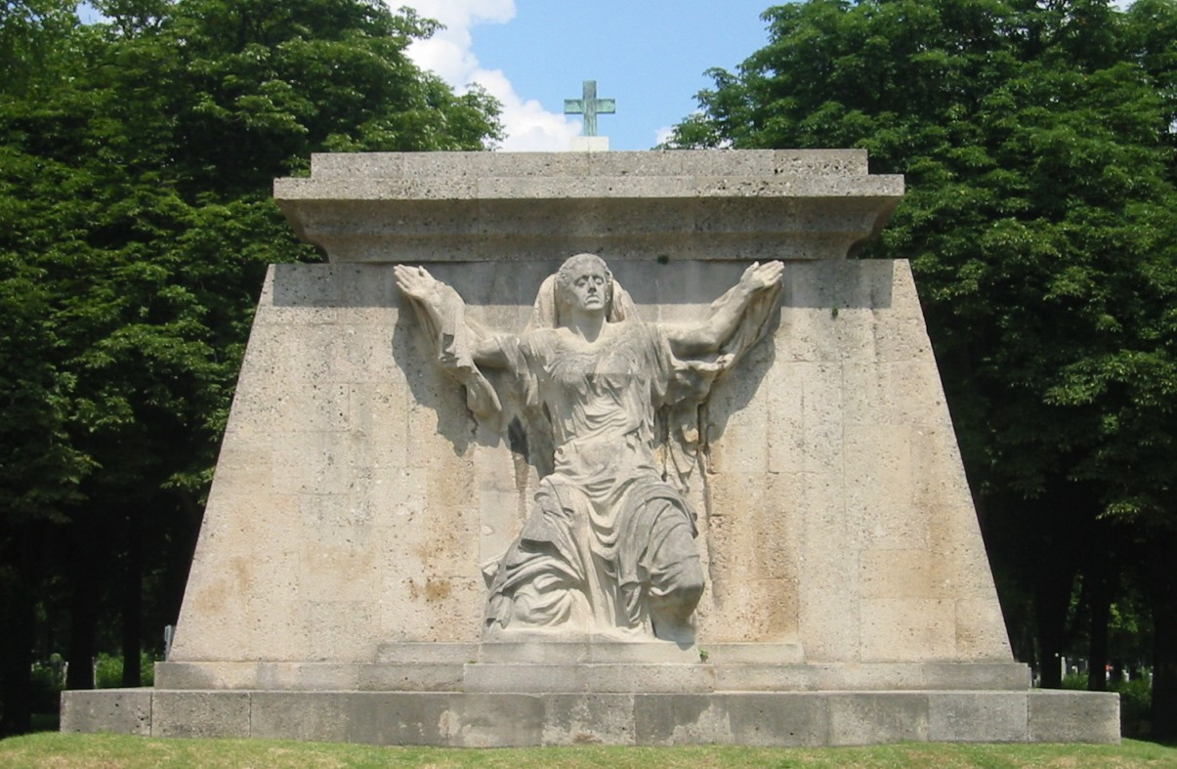
Description of the contents :
War memorial for the victims of World War I
On the cemetery site there are numerous memorial sites and war graves as well as military cemeteries. The largest of those fields of graves are the so-called “Cemetery for the Victims of World War I”, at the front side of which there is a monumental war memorial created by Anton Hanak (born March 22, 1875 in Brno, died January 7, 1934 in Vienna, Austrian sculptor). It shows Our Lady of Sorrows and was carved in 1925 (a model is to be seen at the Hanak-Museum in Langenzersdorf). At the area of Vienna Central Cemetery there is also the Cemetery for the Victims of World War II and the Soviet war graves dating back to World War II, where 2624 Soviet soldiers of the Red Army have been interred (among them twelve ‘Heroes of the Soviet Union’).

