AXIS 3 : museums, historic sites, courses
AUSTRIA

Description - practical information
Practical information:
Name of the museum, site and course : The knight in armour
Address / location : Felderstraße, A-1010 Vienna
Schedule :
Contact :
Website : http://de.wikipedia.org/wiki/Wehrmann_in_Eisen

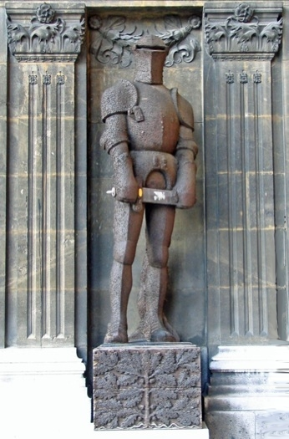
Description of the contents :
The “Knight in Armour” is a relic from the monarchy that was put up again right next to the Vienna Town Hall in 1934, where it is still to be found today – below the inscription by Ottokar Kernstock: “Property and blood for the mother country. Vienna’s “Knight in Armour” is to recall the times when love and compassion were as endless as the suffering of war.” The “Knight in Armour”, which was made of wood by Josef Müllner, was temporarily put up at Vienna’s Schwarzenbergplatz between 1915 and 1934. During World War I different people hammered a nail each into the wooden statue in return for a donation for the imperial war machinery. The first nails were hammered into the statue by Archduke Leopold Salvator, the German embassador Tschischky-Bögendorff and the Turkish embassador Hussein Hilmi-Pasha as a sign of being allies in the war.

