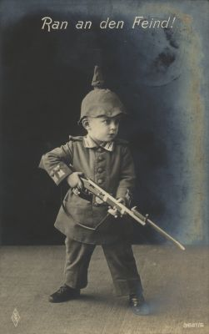

Acknowledgement:
Little boy in a soldier’s uniform, 1917 (PFB publishing house).

Subject / Topic:
- In connection with the photo, the title of the postcard “approach the enemy“ offers the starting point for the reflection of the meaning of children and the youth for the wartime economy.
- Furthermore, the motif can be a reason for the question of the influencing of children and the youth within the war propaganda.

Potential working questions / Working centres:
- To what extent were children and the youth involved in the wartime economy?
- What was the reason for presenting infants as soldiers?
Potential targets:
- The schoolboys and schoolgirls shall be able to understand the militarism in the German empire: The presentation of children in soldiers’ uniforms and above all in sailors’ suits was an everyday occurrence.
- They shall gain a first impression of the “boundless war“which resulted in the inclusion of women and children in the wartime economy.
Use in class:
- The postcard can be used as an example for the consequences of World War I for the civilian population.
- Furthermore, it can be used, for instance, in connection with the wartime economy.

