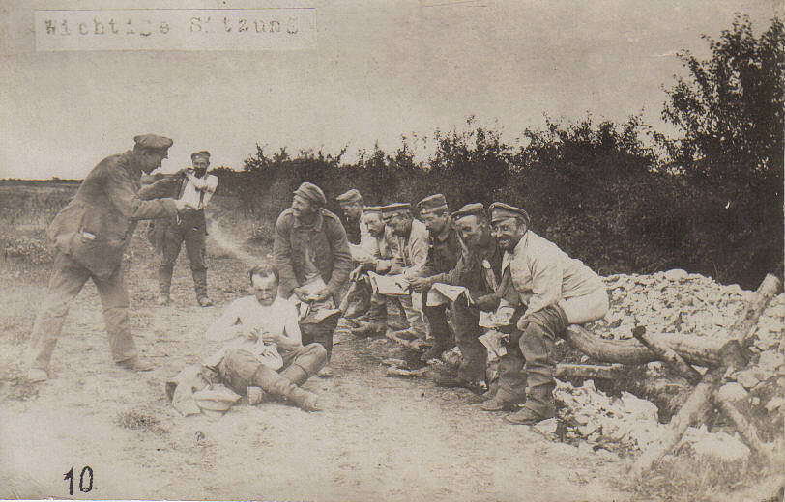
Acknowledgement:
“Important meeting”, without date (private property)
Subject / Topic:
- The soldiers’ life at static warfare
Potential working questions / Working centres:
- Can statements be made regarding the soldiers’ day-to-day life at the front?
- Are these transferable to other European armies?
- To what extent do the laughing soldiers in the postcard correspond to the reality at the front?
Potential targets:
- The schoolboys and schoolgirls shall go into the soldiers’ day-to-day life at the front – in particular into the static warfare.
- The schoolboys and schoolgirls can deepen their competence of photo analysis.
Use in class:
- The postcard can be used in class when the war propaganda is familiar to the schoolboys and schoolgirls in its outlines. In this case it serves the deepening of the already learned competence of photo analysis.

