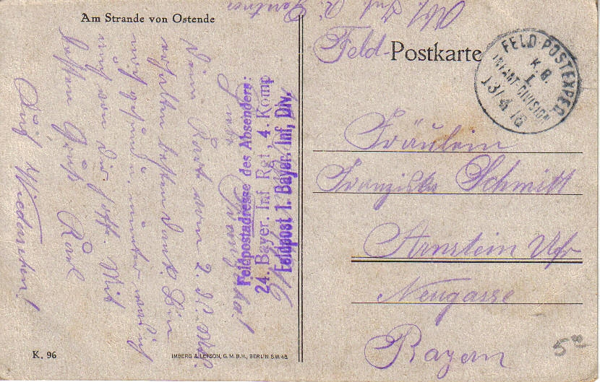

Acknowledgement:
„At the beach of Ostende“, 1916 (Private property) 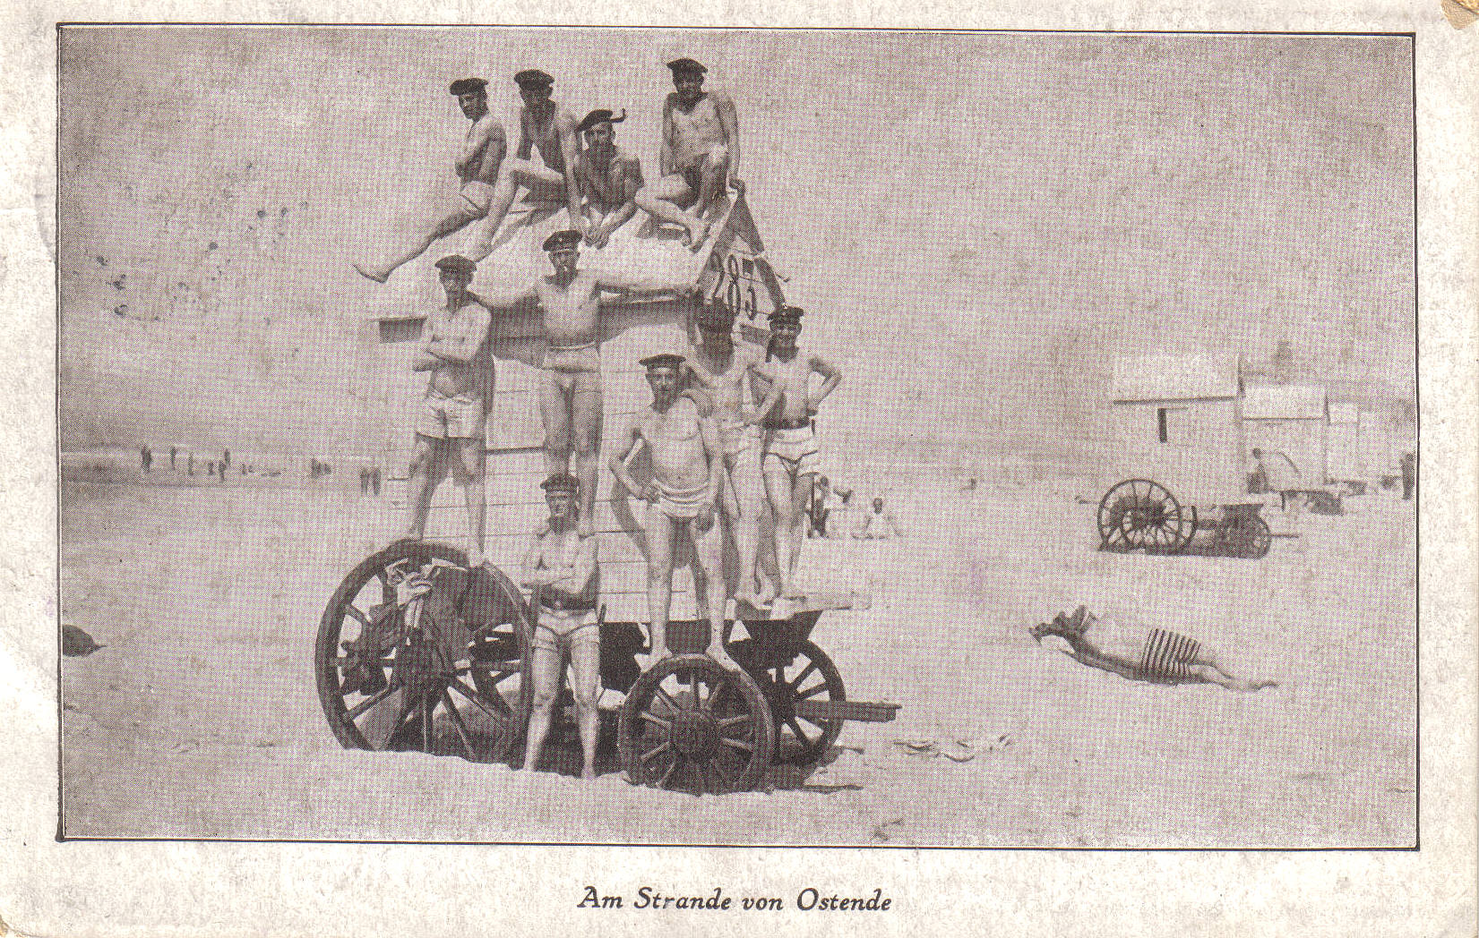
Subject / Topic:
- The German navy: A pleasant summer holiday at the Belgian beach?
Potential working questions / Working centres:
- How do the German navy soldiers present themselves in occupied Belgium?
- Are there any parallels regarding self-projection of other European soldiers on postcards, etc.?
- Were there any reactions of Belgian citizens to the occupying forces?
- The schoolboys and schoolgirls can deal with the naval war between Great Britain and the German Reich.
- The naval blockade of Great Britain in the North Sea.
Potential (subject methodical) targets:
- The schoolboys and schoolgirls shall work out the contradiction between the presentation of the German navy soldiers (they present themselves as if they were on summer holidays) and the brutal sea war by referring to the example North Sea.
- The schoolboys and schoolgirls shall refine their abilities to analyse illustrated sources: They shall expose the presentation as a posed propaganda photo.
Use in class:
- The postcard is suitable for getting a solid grounding in the presentation of the navy.
- The differences between propaganda and reality can be covered.

