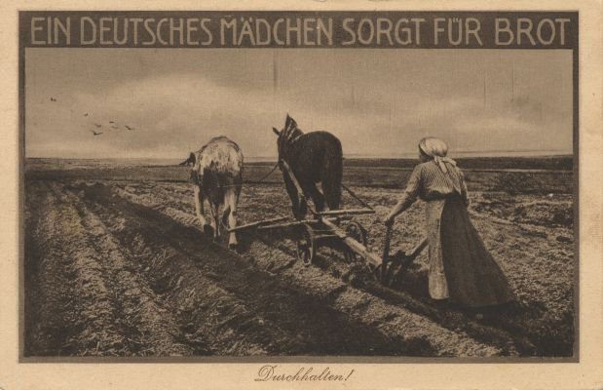

Acknowledgement:
A German girl provides bread. Hold out, 1918
Subject / Topic:
- The title of the postcard: “A German girl provides bread“together with the staying password below, is an opportunity for the analysis of the consequences of World War I for the women’s lives.
Potential working questions / Working centres:
- To what extent were women involved in the wartime economy?
- Why were such staying passwords already necessary in 1918?
Potential target:
- The schoolboys and schoolgirls shall realize the changed role of the woman during World War I: She replaced the men in agriculture and industry to ensure the supply of the population.
Use in class:
- The postcard is symbolic for the wartime economy.
- An European perspective is an obvious example: Were there similar tendencies in other European countries?

