3ème Comité de pilotage  Vienne, Autriche  26 et 27 septembre 2008 | 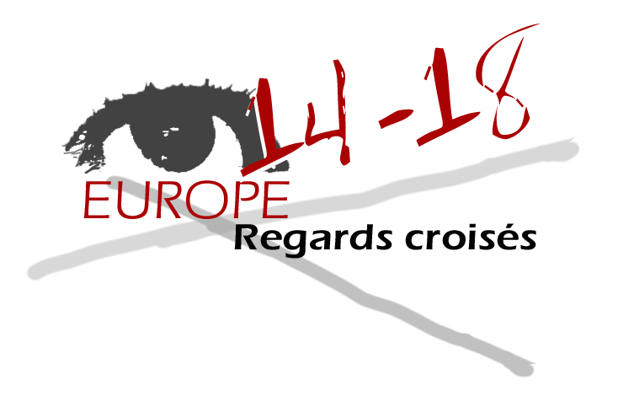

Questions pour l’évaluation externe

1 -Do you think that the contributions in progresse come up with the ojective that was set?

Most of the contributions for the axis 1 and 2 met the requirements. As for the axis 3 and 4 some of the partners haven’t sent their contributions in time or only fragmentary parts. Some participants have not met the dead line up to now.

2 - How do you assess each partner’s involvement during the steering committee, and more generally, in the project?

The presentation of the participants’ contributions was very different. Some presented only a short oral summary of their work while others a very detailed power point presentation or illustrated their contribution by a handout. In general these contributions gave an insight about participants work and were useful for the project.

It was a good idea that the organizers of Vienna piloting the meeting organized a guided tour through the museum for the history of the Austrian army (Heeresgeschichtliches Museum) showing to participants how the WWI was presented. The competent guide gave an actual insight to the topic. It was an exemplary Austrian contribution to axis 3, 4. It would be very useful to implement a documentation of the exhibition on the platform and to prepare a didactic plan for teachers to make use of the exhibition.

3 - What do you think of what was suggested during the steering commitee and of the way things were managed. (Time management – balance between the different activities…).

From my point of view the timetable for the next step is realistic but the partners should be more disciplined to fulfil the project.
The key element is the platform. On one hand the layout (buttons) will be modified step by step to create the module for training and further education. Consequently, a much easier use will be necessary. Maybe it would be helpful to implement a browsing function because it is not always simple to find documents.

The new categories for the module were settled in Vienna:

- Reasons for the war
- Key events/ course of events of the war
- Aspects of the total war
- The Treaties and their aftermaths

For all these parts it is necessary to load documents (audiovisual or written sources) as well as didactic ideas and examples of good practice for the project.
On the other hand a forum will be activated for the communication between the partners as well as between the partners and teachers who run the project.

A problem will be the idea that partners should translate the contents of the final version in their mother tongue because not all have experienced translators and professional translators are very expensive.

4 - According to you, did this steering committee give you a clear insight about the project progress and its achievements?

Yes the partners presented their material and the greater part was implemented in the meantime.

5 - What do you think of the plans of action that have been set so as to provide the both the internal and external communication.

During step one (up to Vienna) the communication was running by mail between partners (internal communication) and monthly newsletters (external communication). As for step two a forum was introduced, which will be more efficient, because all partners can read and participate to the chat room.

6 - At this stage of the development of the project, are you already able to detect the benefits it could bring to the teaching community?

For the moment a lot of material has been implemented and provide an opportunity for a multi perspective point of view in the fields of WW I. It would be helpful to build training session plans for teachers with educational objectives.
A problem will be that in some countries like France the curricula are very strict and teachers will have no time to experience the new material in the summer term if that topic is taught during winter term.

