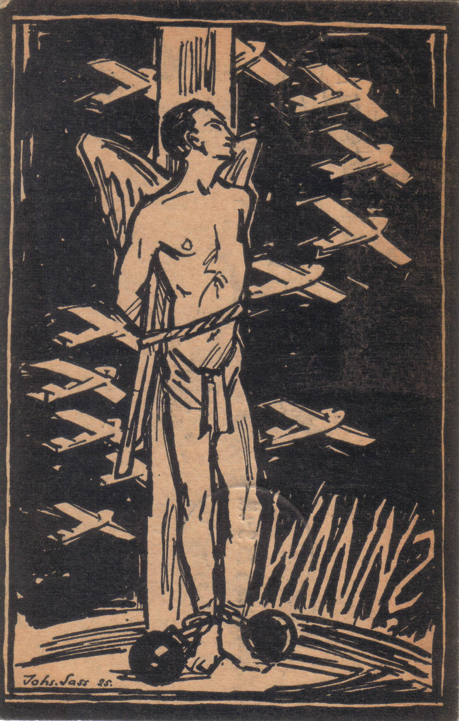

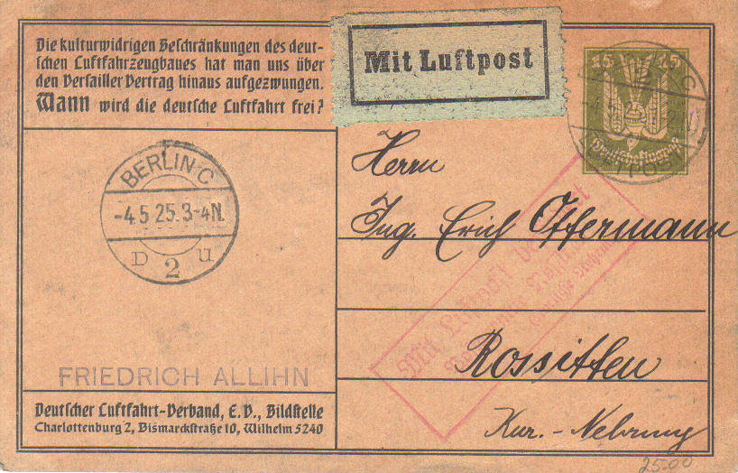
Acknowledgement:
Johannes Sass, 1925 (private property); the postcard was published by the German “aviation association; the subject comes from Johannes Sass

Subject / Topic:
- The subject or topic for the lessons arises from the text on the back of the postcard: “The adverse cultural restrictions of the German aircraft construction have been forced to us enduring the Treaty of Versailles. When will the German aircraft be free?” Therefore, a connection to the perception of the Treaty of Versailles in the industry, the population or in the aircraft association can be made.

Potential working questions / Working centres:
- Which conclusions can be drawn from the motif to the self-perception of the German aviation association?
- Is the request of the German aviation association representative?
- The symbolism of the postcard: The German Eagle is presented like an angel.
Potential learning target:
- The schoolboys and schoolgirls shall realize the resistance of single groups by taking the resistance of the aviation association towards the Treaty of Versailles as an example.
Use in class:
- The postcard is suitable for talking with the schoolboys and schoolgirls about the Treaty of Versailles.
- An European perspective is an obvious example, by taking into consideration as well the perspectives for example of the French and the English towards the Treaty of Versaille.

